

VITAGRAPH FILMS ACQUIRES NORTH AMERICAN THEATRICAL RIGHTS TO
JASON WISE’S SPIRITED DOCUMENTARY, WAIT FOR YOUR LAUGH,
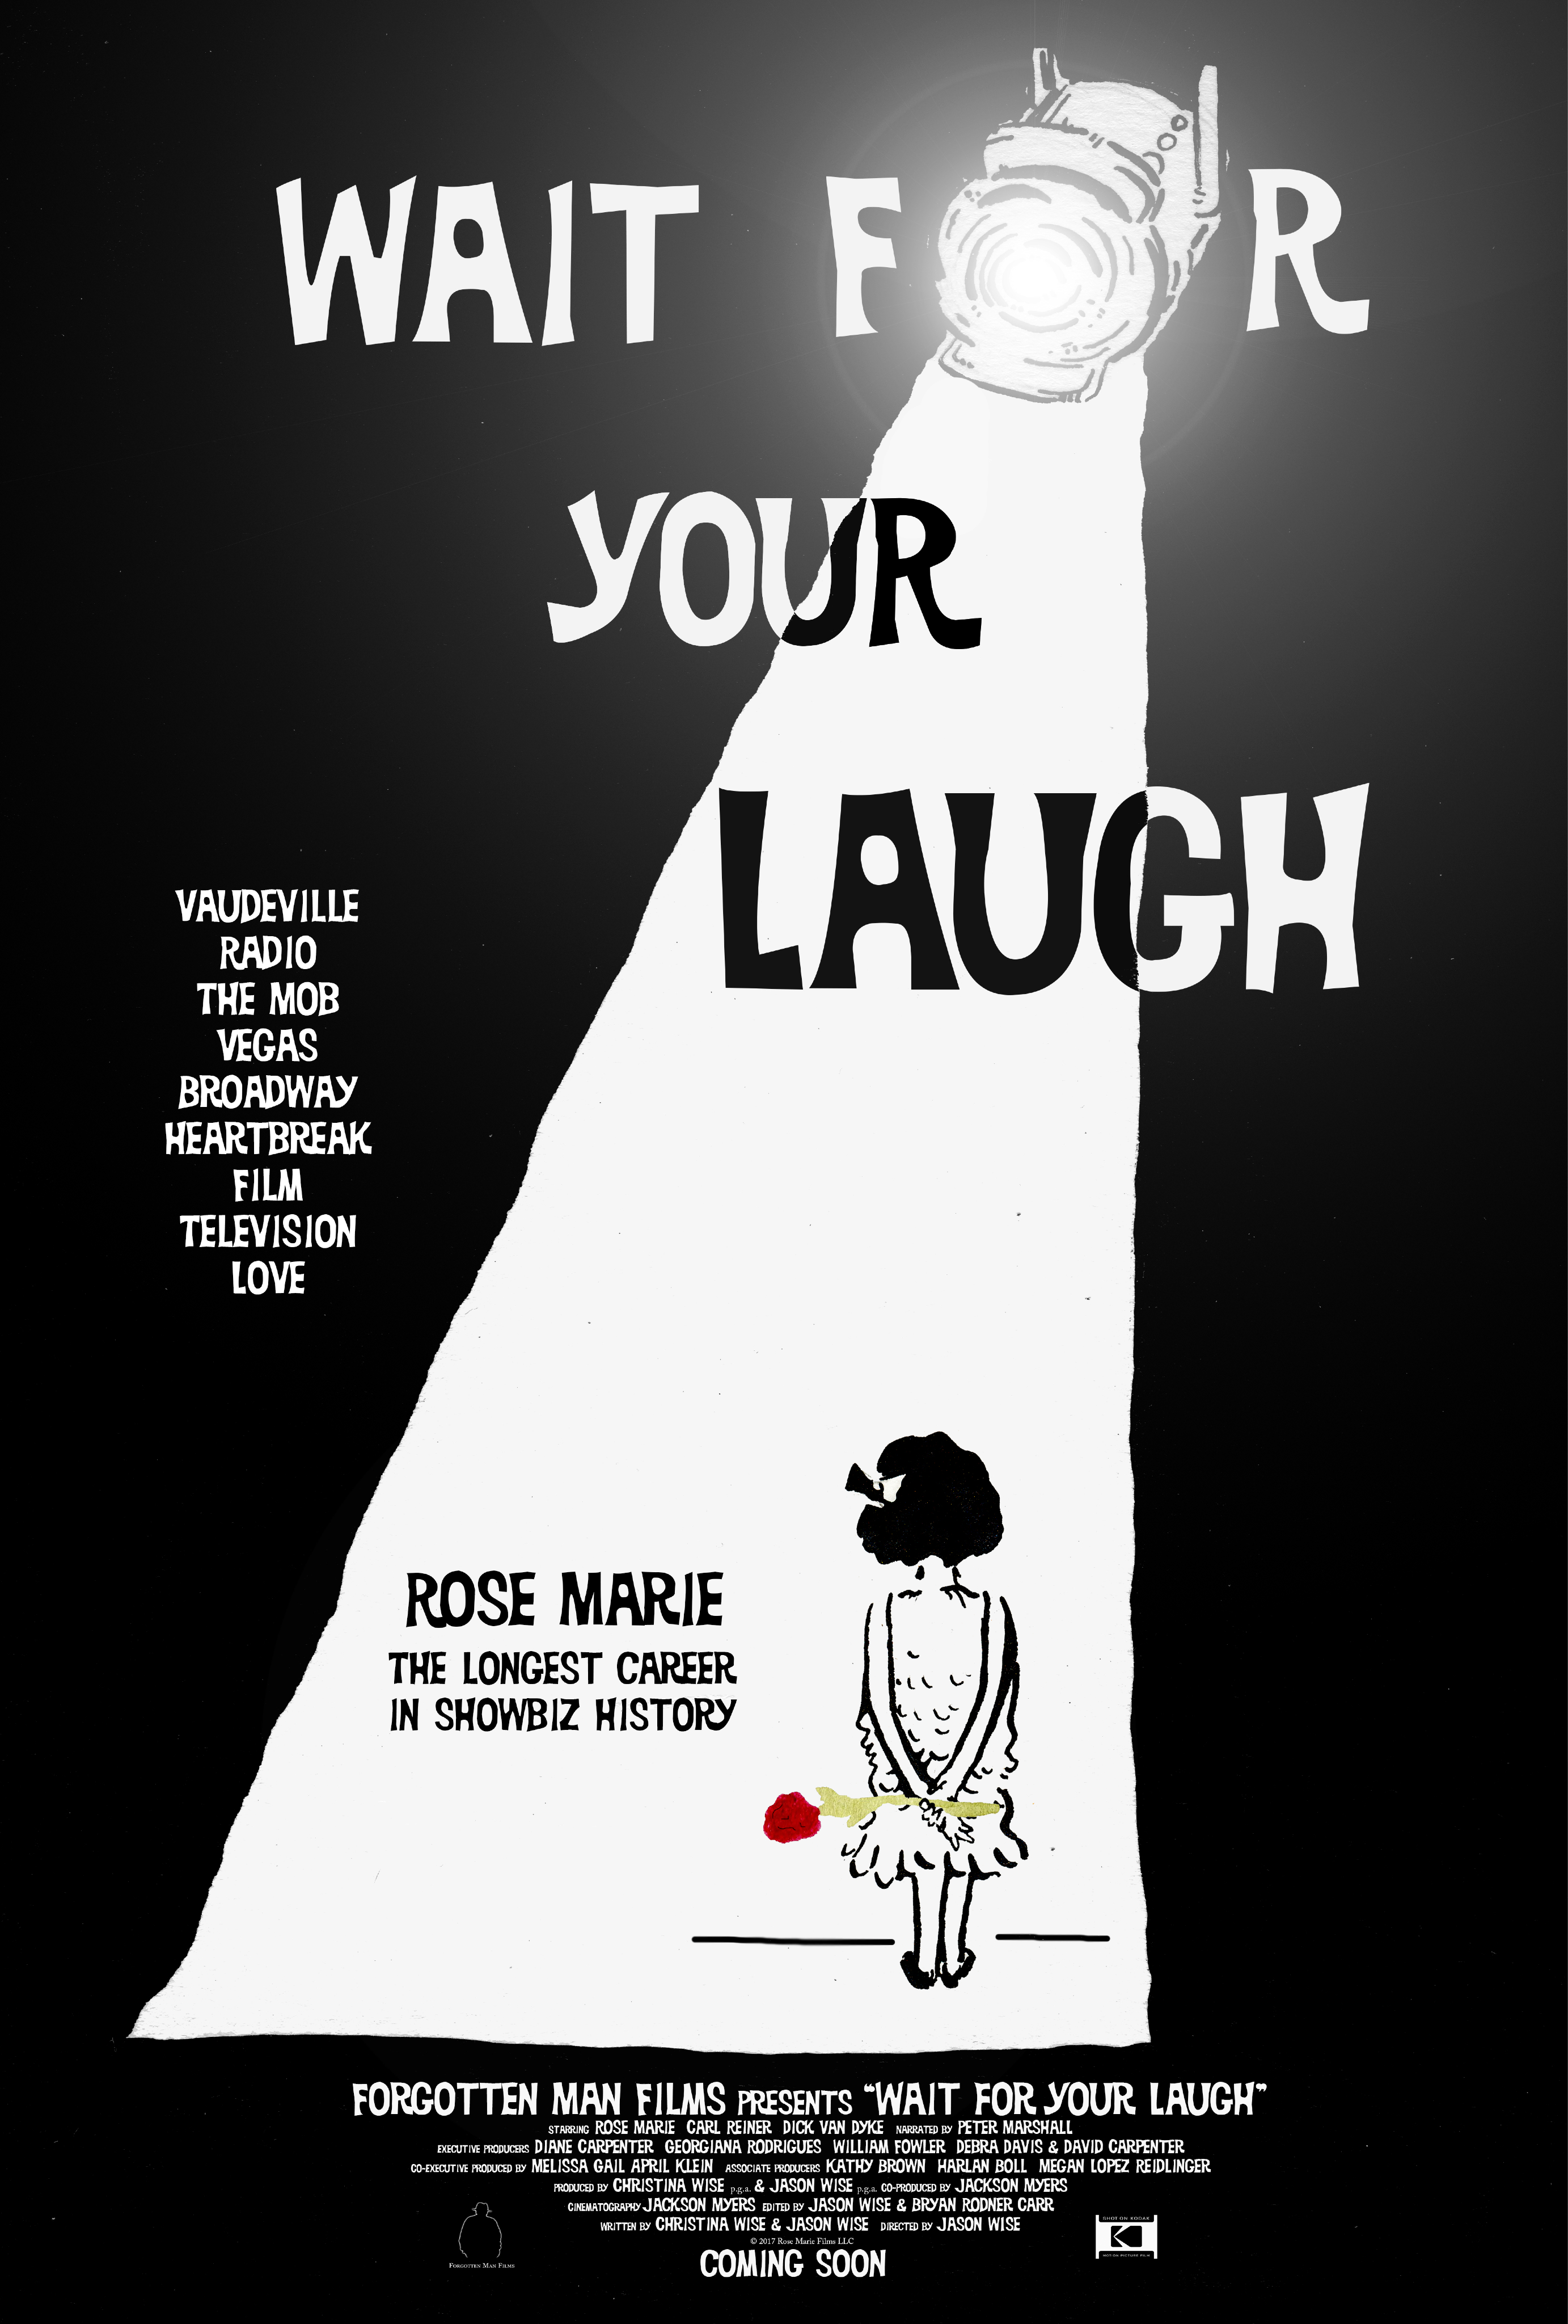
HIGHLIGHTING THE EPIC LIFE AND CAREER OF ROSE MARIE

New York, NY – October 13, 2017 – Vitragraph Films announced today that they have acquired North American theatrical rights to WAIT FOR YOUR LAUGH, filmmaker Jason Wise’s (SOMM) spirited and fascinating documentary highlighting the epic life and career of Rose Marie, one of the most brilliant comediennes of the last century. The film, produced by Christina Wise and Jason Wise in association with Forgotten Man Films, was the Opening Night selection at the 2017 Mill Valley Film Festival. Vitagraph Films will launch the North American theatrical rollout starting on November 3th in New York City, rolling out on November 10th in San Francisco and November 17th in Los Angeles followed by select cities nationwide. The theatrical deal was negotiated with Vitagraph Films Founder and President David Schultz with Brian Reshefsky on behalf of the filmmakers.
She's "left them laughing" and applauding for nine decades, as she traversed through every 20th century entertainment medium that ever was as a singer and brilliant comedienne. With "The Dick Van Dyke Show," she was part of the cast of one of the most iconic television shows of the 1960s and what's more, she played a lady TV writer who held her own with the boys, thus, planting the seed in the minds of her viewers, that girls could grow up to have interesting and creative jobs too! Having begun her epic career in vaudeville at the age of three, performing is in her muscle memory. She professes to still go over her act in her head... Meet Rose Marie. She's now 94-years old.

WAIT FOR YOUR LAUGH tells the story of the longest active career in entertainment, but it also looks at what it was like to be a female performer in the 20th century, to work through periods of extreme personal heartbreak and it casts an eye on how Rose Marie and her fellow nonagenarians Dick Van Dyke, Carl Reiner and Peter Marshall, still have the drive to create.

Shot on 35mm and 16mm film stock, the film will be projected where possible, as a 35mm printed. The film contains amazing behind-the-scenes color footage from Rose Marie's personal collection, chronicling what went on backstage on "The Dick Van Dyke Show" and other sets where she worked.

Far more than just sassy Sally Rogers on "The Dick Van Dyke Show," and the top center square on "Hollywood Squares," Rose Marie worked in every facet of showbiz. She was "the darling of the airwaves" at the age of four and went on to work in vaudeville, Vegas, Broadway, movies, television, theatre, concert halls and nightclubs. Along the way she was known as "the kid" by the mob. She called Al Capone, Uncle Al, opened the Flamingo at the birth of Las Vegas, for Bugsy Siegel, and had her career protected and nurtured by "the boys" who controlled so many nightclub stages across the country, live performers couldn't help but be in bed with the mob.

ABOUT JASON WISE
In 2012, Jason directed the acclaimed wine documentary SOMM which put the existence of the sommelier into the American consciousness and was one of the most watched documentaries of the year. SOMM was turned into a television series by Esquire Network titled UNCORKED in 2015, and Jason served as an executive producer of all six episodes. In 2015, Wine Enthusiast Magazine named Jason one of the “40 Most Influential” people in the world of beverages under the age of forty. Jason’s follow-up film to “SOMM: Into The Bottle” was recently released worldwide by Samuel Goldwyn Films and spent several weeks as the number one documentary on I-tunes in the United States, Canada, Germany, and the UK. Jason’s next film, WAIT FOR YOUR LAUGH about nearly 90-year career of showbiz performer Rose Marie, will be released in theaters by Vitagraph films in 2017. Wise has several other feature films in preproduction.

ABOUT FORGOTTEN MAN FILMS

Forgotten Man Films is a new production company focused on non scripted feature films in the food, wine, and biography genres created by Filmmakers Jason Wise, Christina Wise, and Jackson Myers. Forgotten Man Films previously produced the acclaimed wine documentary SOMM and it’s sequel SOMM: Into the Bottle. Wait for Your Laugh will be the third theatrical release for the company. http://www.forgottenmanfilms.com

ABOUT VITAGRAPH

Vitagraph Films is a full service theatrical distribution company. Recent releases have included the documentaries FOR AHKEEM and LETTERS FROM BAGHDAD. Vitagraph Films released the Spirit Award nominated Brazilian feature AQUARIUS starring Sonia Braga in 2016. Other select titles includes VALENTINO THE LAST EMPEROR, THE BAADER MEINHOFF COMPLEX, EVEN THE RAIN and Takashi Miike’s AUDITION.

For more information about the film, please visit the WAIT FOR THE LAUGH official website:
http://www.rosemariemovie.com

